1. Average Resistance:

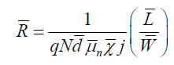

1. Actual Resistance: (Resistance value Margin)

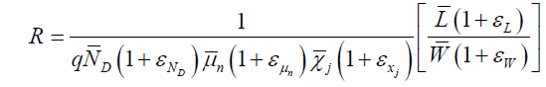

1. Uncertainty Resistance:

